Quickstart JS Screenshots

1> Video Quickstart.

Room SID : RMf60838f1b4c2698b069b1abbea1cc3c3

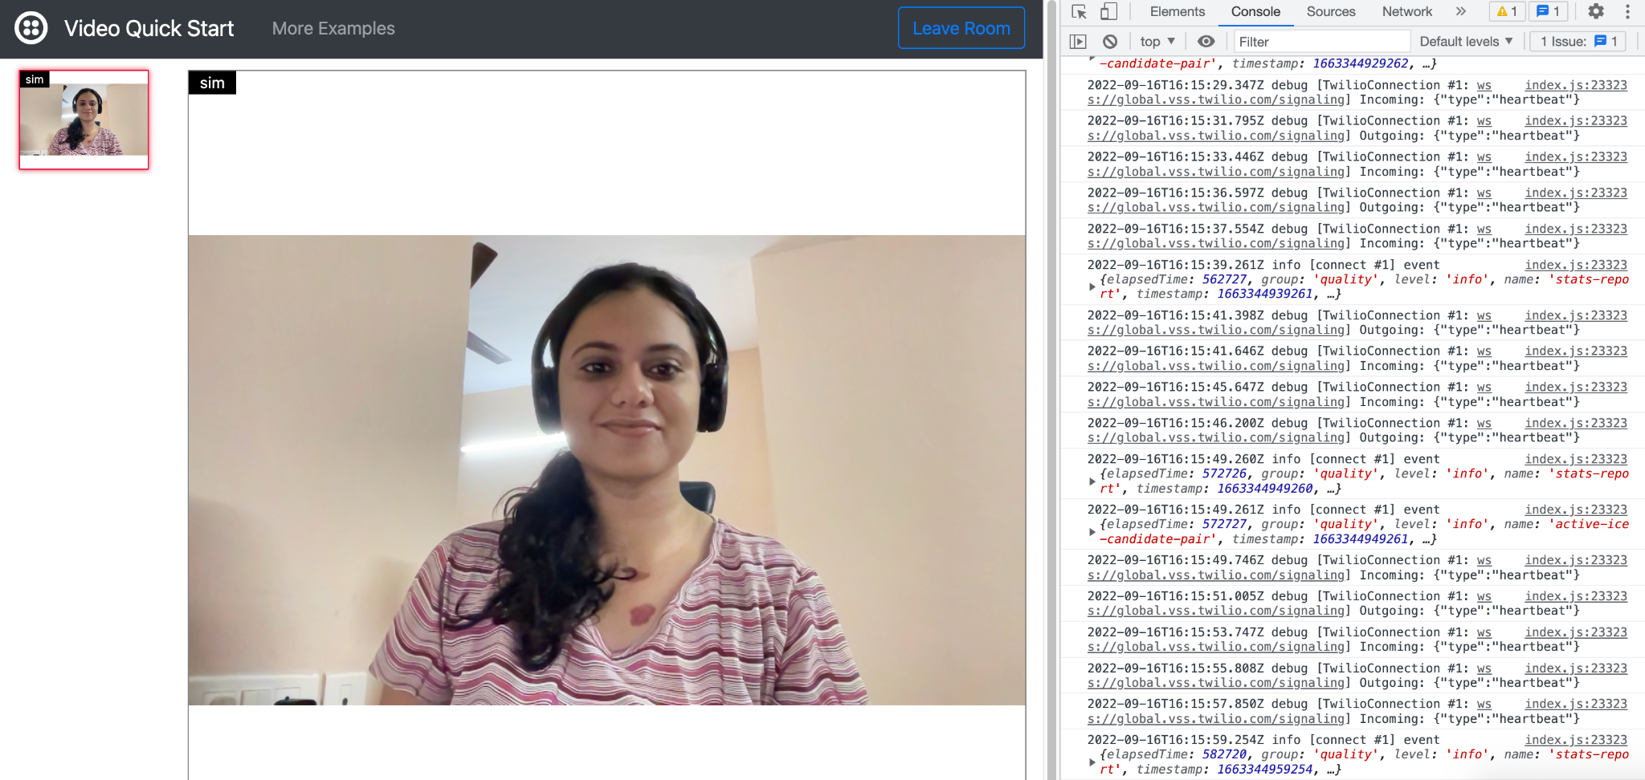

2> Status callback Information :

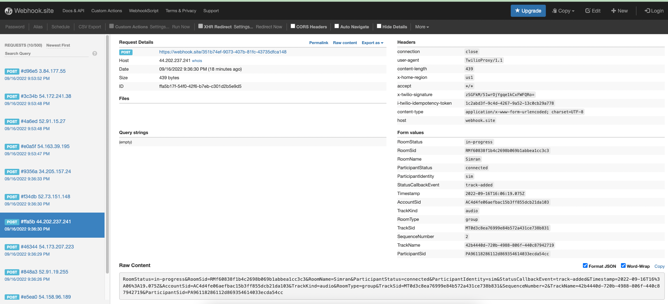

3> Example 1 : Bandwidth Constraints

Room SID : RM00a9220a33e723b6949eb2126e9b5455

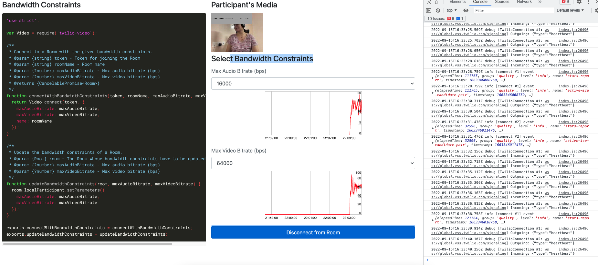

4> Example 2 : Local VIdeo Filter

Filter not working.

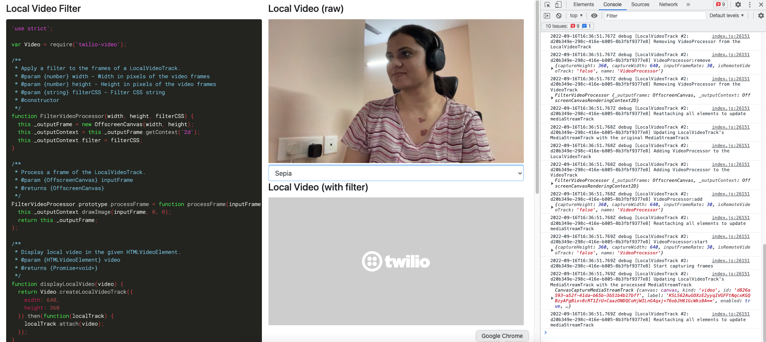

5> Example 3 : Local Video Snapshot

Snapshot

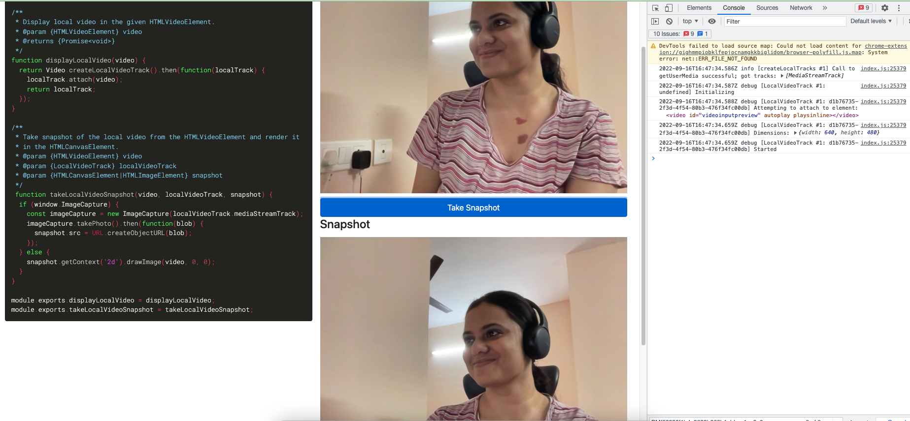

6> Example 4 : Media Device Selection

Room SID : RM6389eaaf46f1280af97abd5f19a4ec06

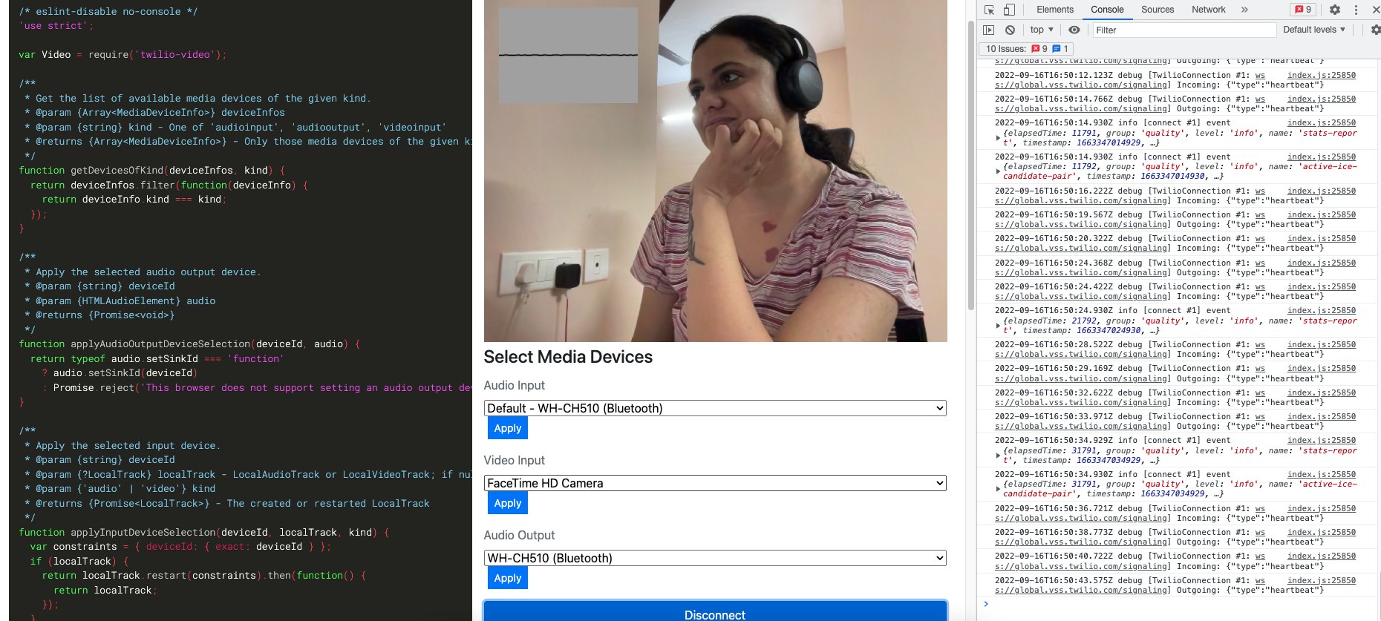

7> Example 5 : Codec Prefrences

Room SID : RMffe85143be35e8ddc78840b8487567d1

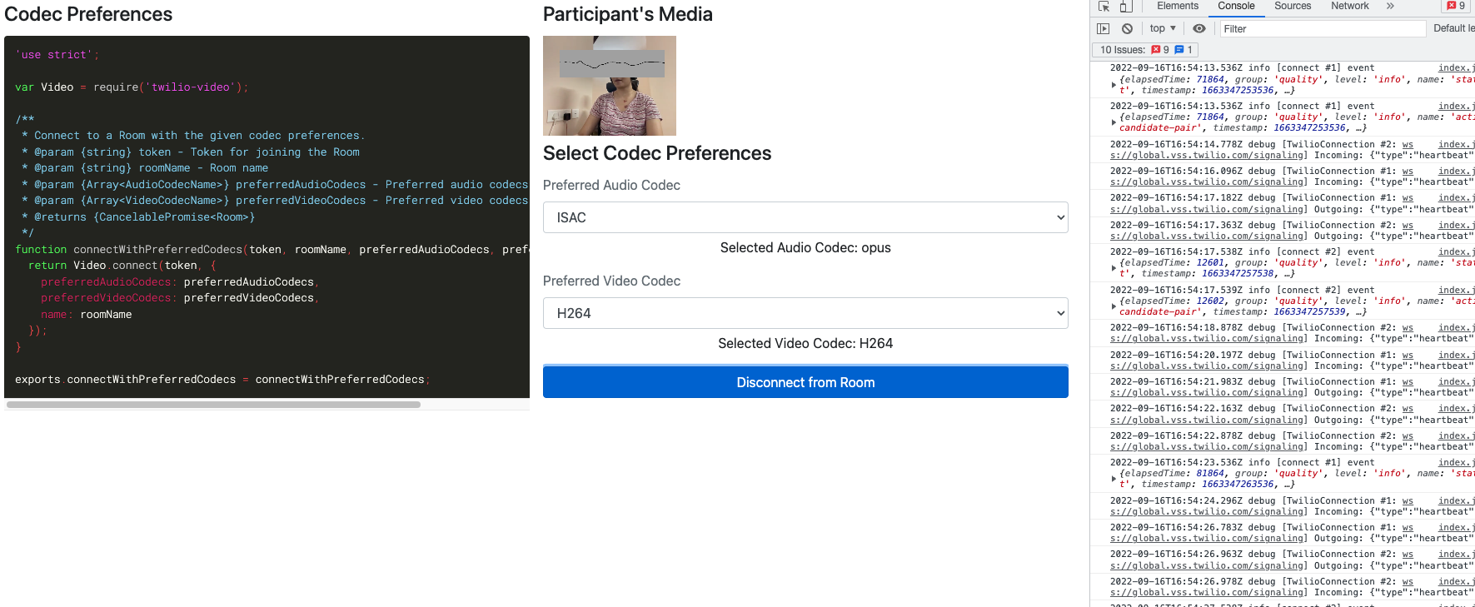

8> Example 6 : Share your screen

Room SID : RM9b38455a83ca01735d58020df77e78b5

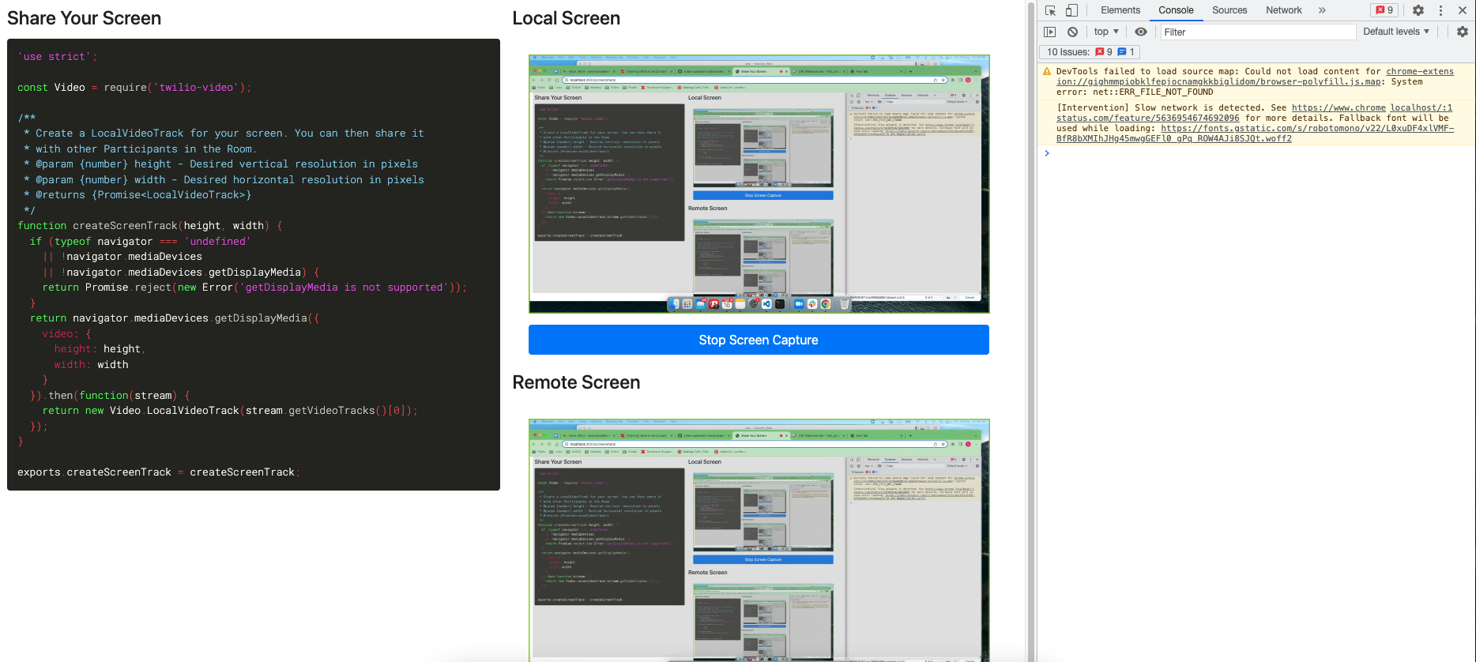

9> Example 7 : Dominant speaker detetction

Room SID : RMf8fe95d44f3c11033aa69397ac12846f

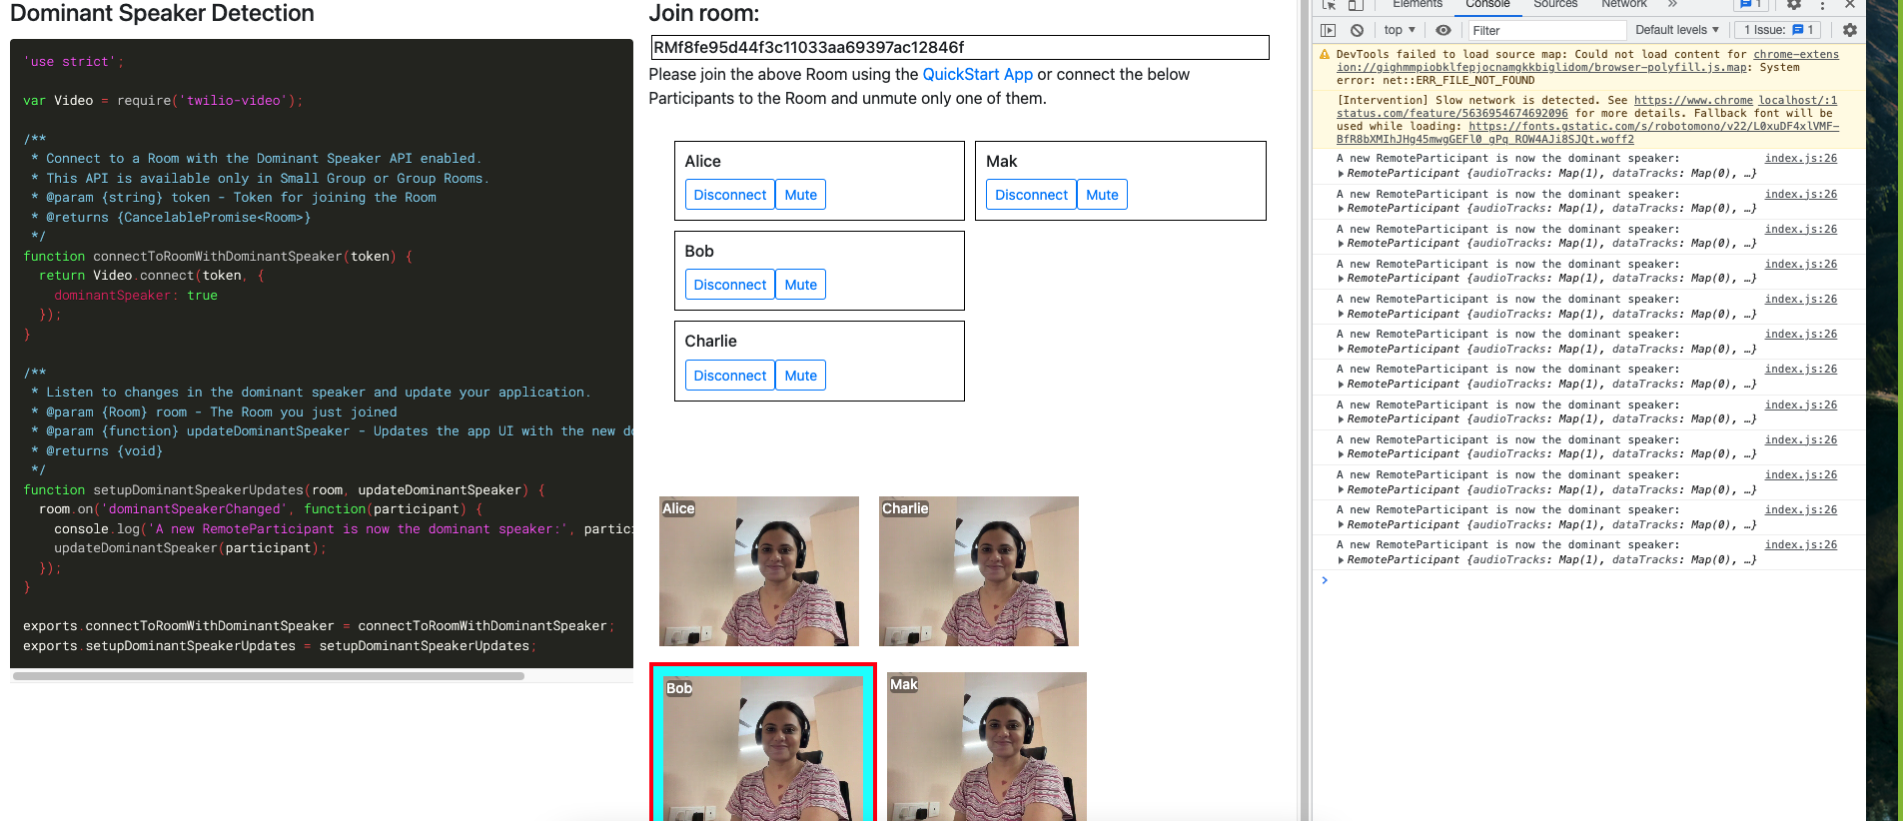

10 > Example 8 : Reconnection States and events

Room SID : RM030d09cbb89012ec9a6be6de180ce17e

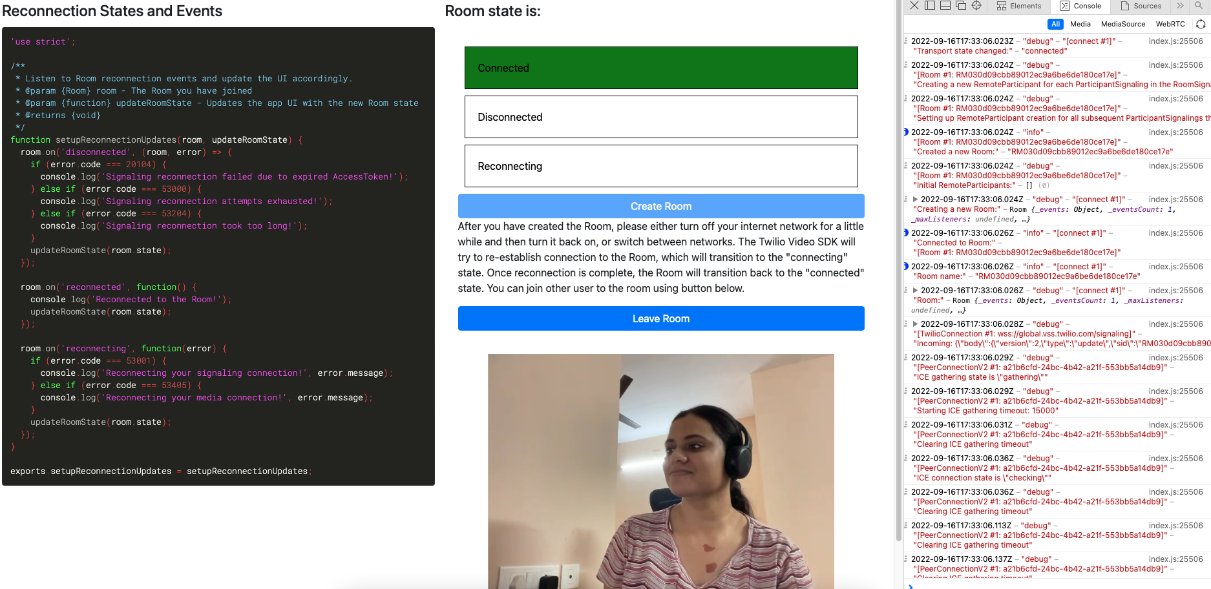

11> Example 9 : Network Quality

Room SID : RMbafa1461da739bb4f29d1eac925f188e

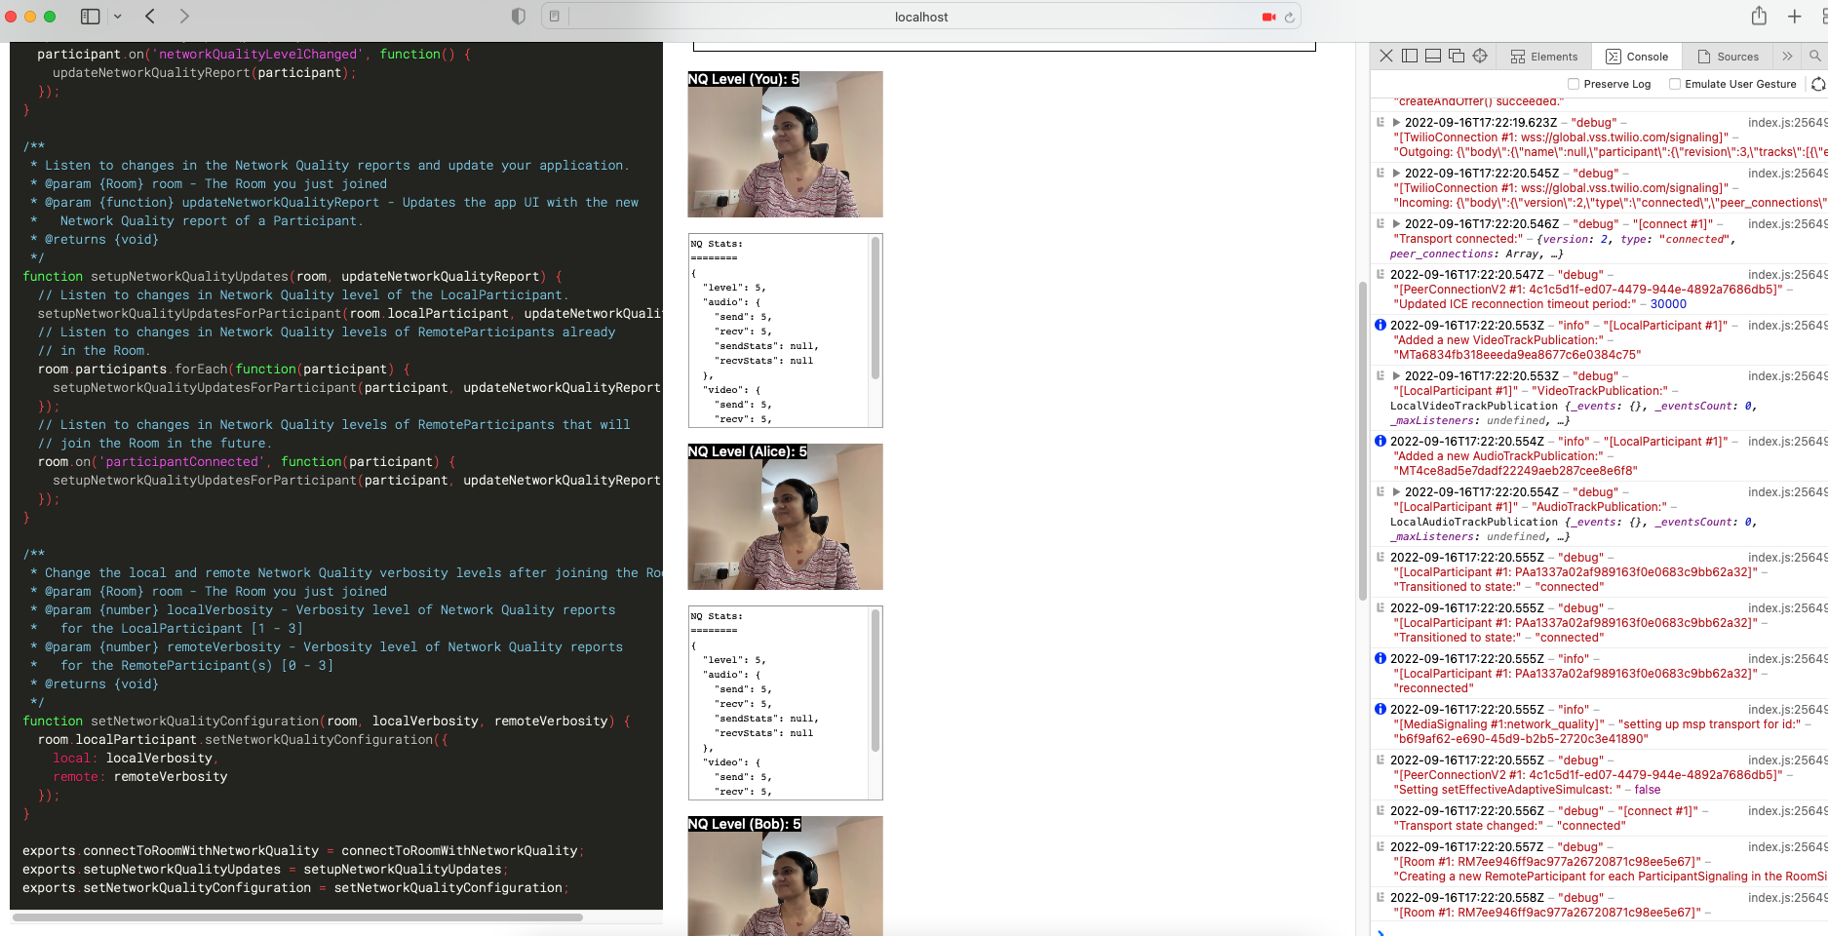

12> Example 10 : Enabling and Disabling Tracks

Room SID : RM63fe7840b8a13e21b6ce94d8f4a693ff

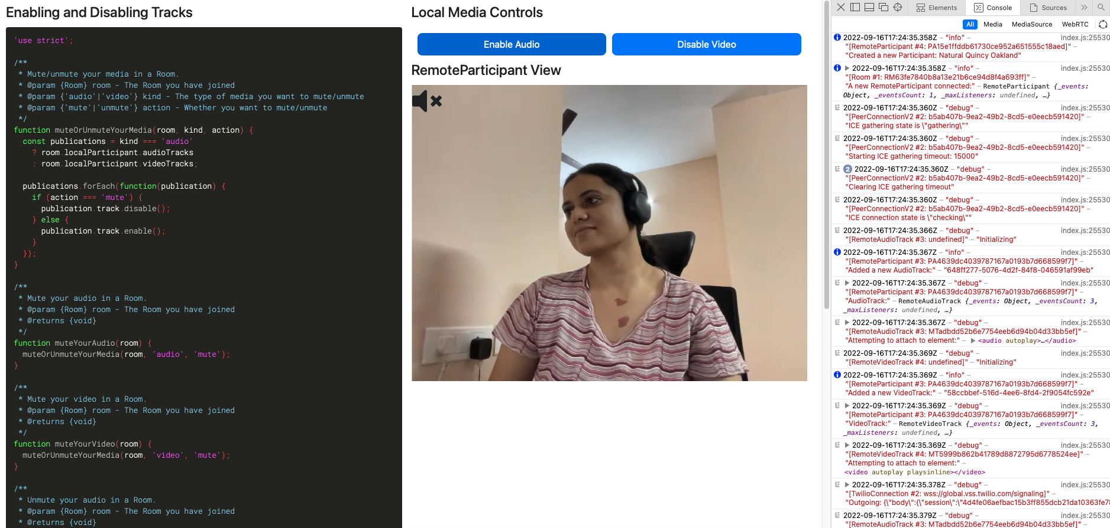

13> Example 11 : Remote Participant Reconnection States

Room SID : RMabdad8f17b46203537cb72889e6f88a2

Reconnecting :

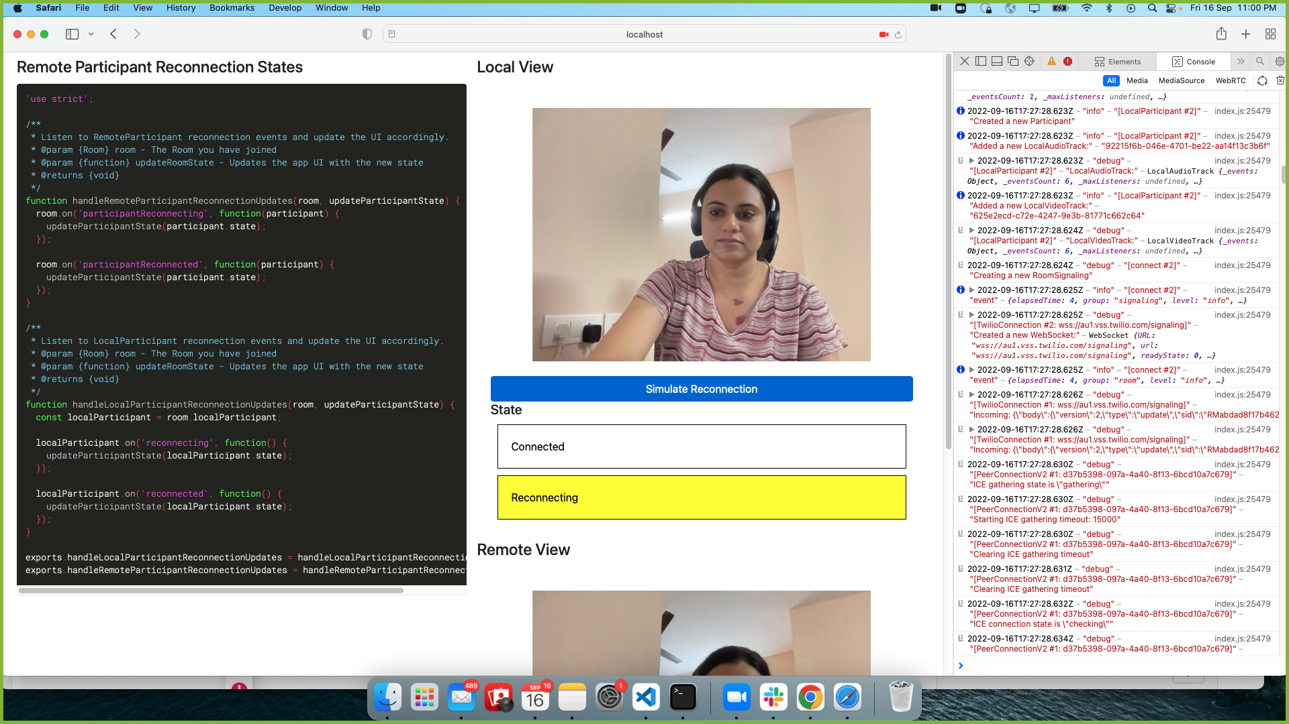

Connected :

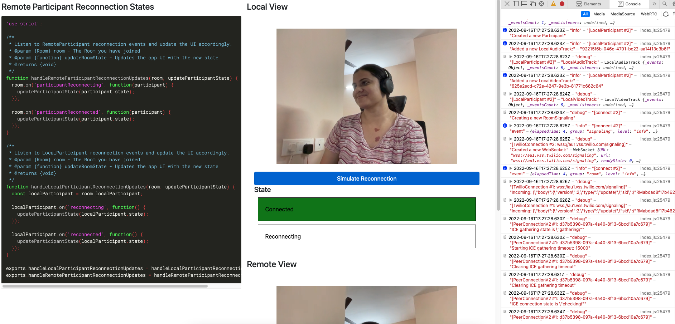

14> Example 12 : Data Tracks

Room SID : RM89d1b7f2698ab1819709b1ea32188588

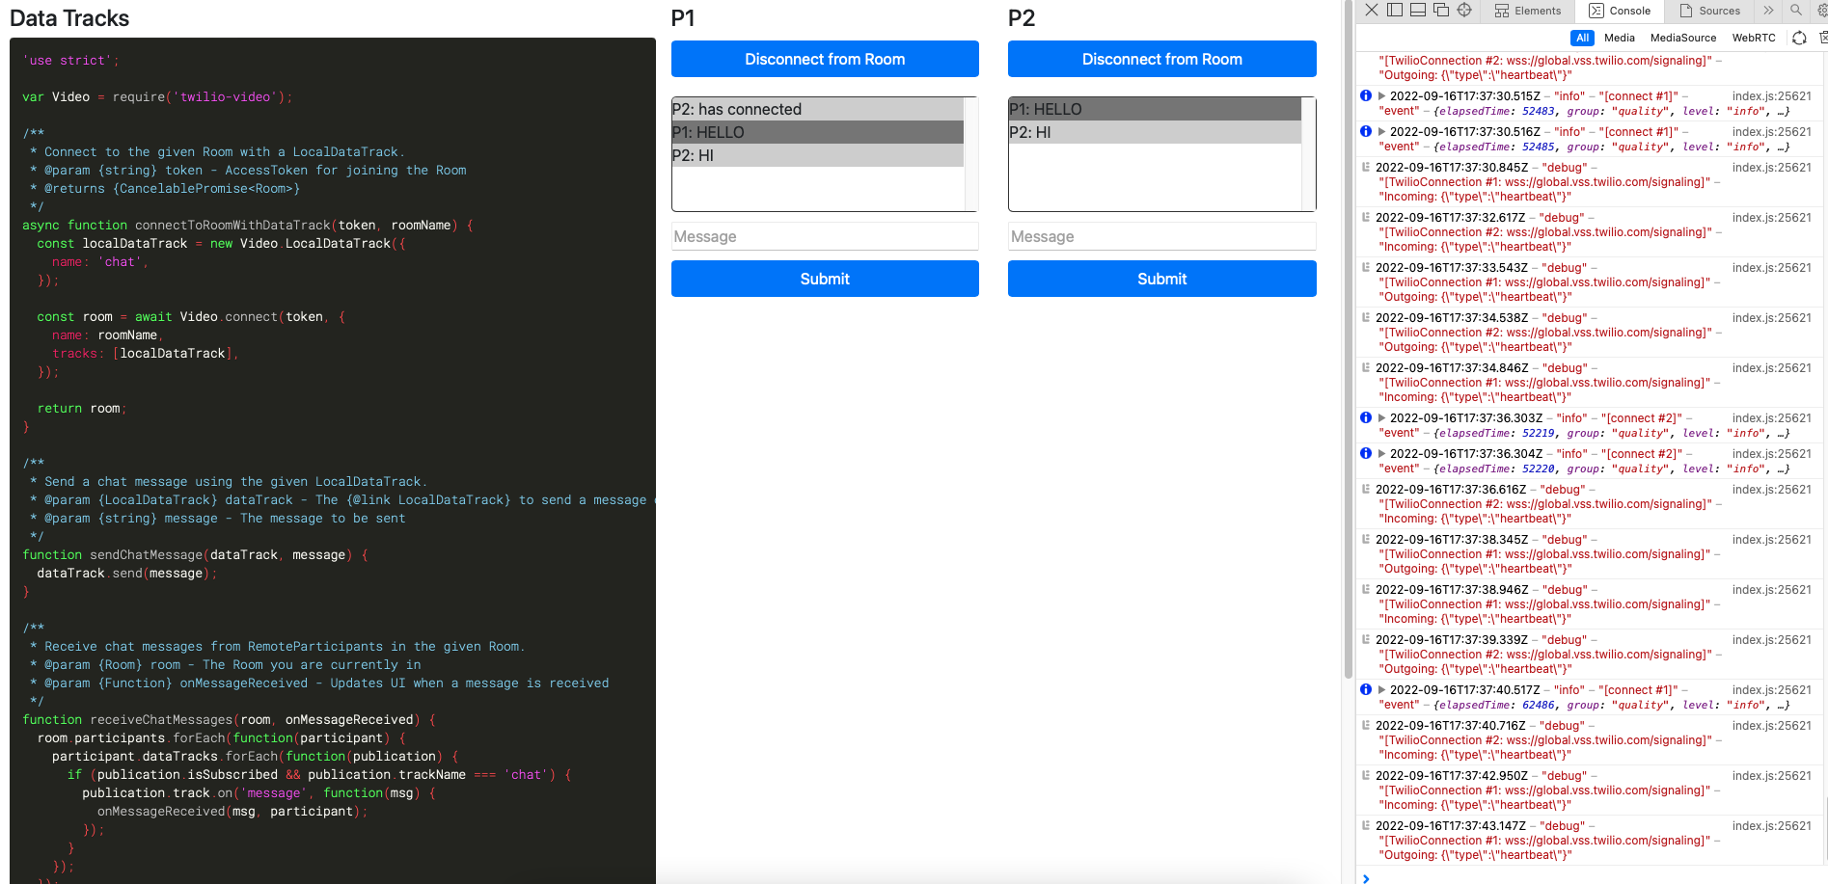

15> Example 13 : Video Track Manual Controls

Room SID : RM4266eaab67a35c001a5d9c04d13ffd3a

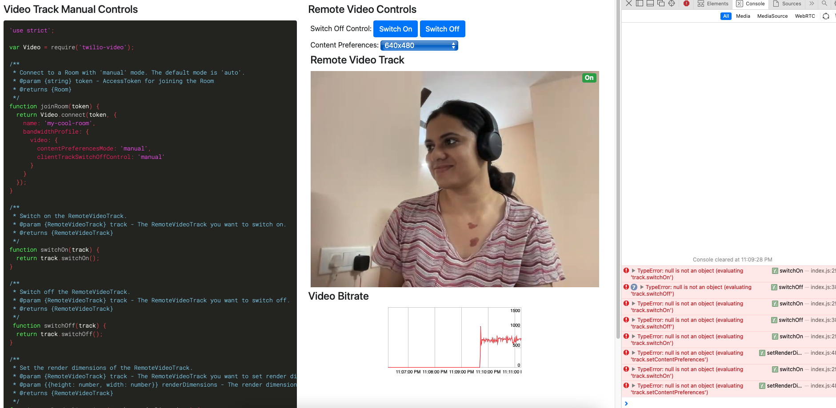

16> Example 14 : Video Track Automatic Controls

Room SID : RM154568f59125181d4d1c8fc30bc1704a

